Configuring a network for secure wireless authentication on kali 2022.4
Creating your own local Certificate Authority and FTP service to test wireless network designs
The walkthrough used here is heavily derived from the sources listed at the end of this document and builds on earlier labs where you setup and configured your devices to serve as a wireless client and an access point.

How to understand the instructions:
Bolded text is an actual text to type at the command line
File names will be italicized (they may also be bolded if they are part of the command you need to enter in the terminal.)

Included screenshots are for reference only. Specific values and interface names are going to be specific to your machine and may not be identical to those presented here. Pay attention to your machine output and make the appropriate substitutions.

Boot the machine, open a terminal window and switch to the root account.

Switch into the root account

sudo su

password is kali

Install required applications, if not already installed

apt update
apt install vsftpd freeradius firewalld

If any of these applications are not available in the default repositories, refer to the instructions in earlier labs on how to add new repositories.

Config vsFTP

Prepare FTP storage directory location
Create public directory for ftp.
mkdir -p /var/ftp/pub
The -p option creates any parent directories that do not exist between the /var directory and the /pub directory.
Check user and group ownership.
ls -l /var/ftp/pub
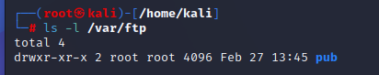
notice the the user and group owner is root.
We need to change ownership to permit anonymous downloading from the public ftp directory.
Change ownership to nobody and nogroup. Then verify.
chown nobody:nogroup /var/ftp/pub
ls -l /var/ftp
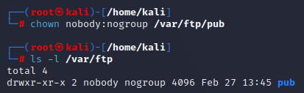
Create a test file that you’ll later for testing.
echo “vsftp file for testing” > /var/ftp/pub/test.txt

Modify config file for vsftp to permit anonymous FTP access
Check current systemctl status for the FTP service.
It should be dead. Start it.
systemctl status vsftpd.service
systemctl start vsftpd.service

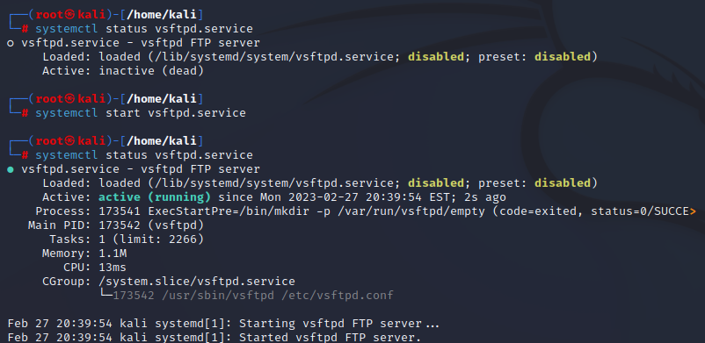
Modify vsftp.conf file in /etc
nano /etc/vsftp.conf
Search for the following 2 settings and modify to match these settings”
anonymous_enable=YES
make local_enable=NO
At the end of the config file add these custom additions:
# Point users at the directory we created earlier.
anon_root=/var/ftp/pub
# Stop prompting for a password on the command line.
no_anon_password=YES
# Show the user and group as ftp:ftp, regardless of the owner.
hide_ids=YES
# Limit the range of ports that can be used for passive FTP
pasv_min_port=40000
pasv_max_port=50000
(note the range of ports. If we configure a firewall, the firewalld config file may need to be modified – details to come later)
Restart vsftp service for force the modified configuration file to be re-read and verify
systemctl restart vsftpd.service
systemctl status vsftpd.service
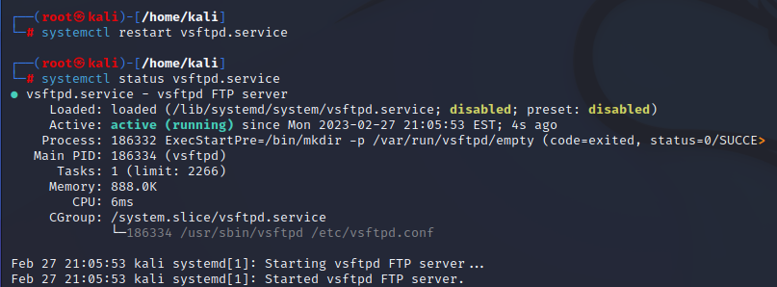
Test FTP access from the command line:
NOTE: Modern browsers no longer support the ftp protocol so you have to use the command line or a dedicated FTP application.
ftp localhost
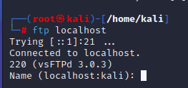
Login Name: anonymous
type help to see list of available ftp commands
type ls

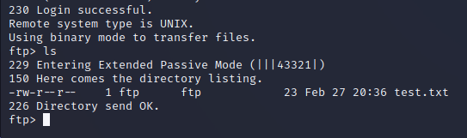
You should see the test.txt file we created earlier
You can download it to verify FTP works if you like but it’s not required at this time.
When you get the simulated version you will need another simulated wlan inter and attach the ftp service to that interface and make sure the firewalld ftp services are attached to that interface. Instructions for that config will be later.

Preparing system for EAP-TLS secure wireless authentication

Need a Local Certificate Authority

We are going to be generating some keys and certificates and they need to be saved somewhere that can be referenced. We will keep it simple for now.

mkdir /etc/certs
Move to that dir so all keys and certificates get placed there
cd /etc/certs
Our Radius server needs to send it’s signed and verified certificate to the supplicant to so the supplicant can verify it’s identity (non-repudiation) and use that certificate to encrypt it’s “fake” temporary certificate back to radius server to generate a bidirectional encrypted communication where actual authentication credentials can verified by the radius server.
Generate a local key for the CA
openssl genrsa -out localKaliCA.key 2048
Local CA needs to generate it's own root certificate. This certificate will be signed with the key we just made to verify root certificate is signed by this specific local CA.
We will call this local CA root certificate: LocalKaliCA_root_certificate.crt
openssl req -new -x509 -days 365 -key localKaliCA.key -SHA256 -out LocalKaliCA_root_certificate.crt
complete the fields according to the screenshot below:
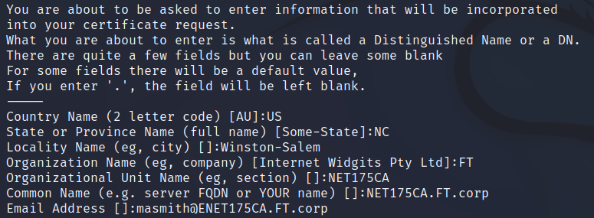
You should now have two files: localKaliCA.key (your CA key) and LocalKaliCA_root_certificate.crt (your CA root certificate).

ls -l
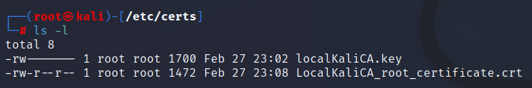
This certificate is the certificate that verifies this machine as a CA and verifies that fact by signing it with it’s key.
We need to convert the format of our .crt files to .pem format (Privacy Enhanced Mail) for use with our RADIUS server (we can actually just change the file extension but, you know, we should to it the proper way…:) ).

openssl x509 -in LocalKaliCA_root_certificate.crt -out LocalKaliCA_root_certificate.pem
openssl x509 -in RADIUS_server.crt -out RADIUS_server.pem

The RADIUS service will need a key to sign a request for a certificate from our local CA
The RADIUS service needs have our local CA vouch for the identity of our radius server.
To do that we need to create key for the RADIUS and use it to sign a certificate signing request requesting the local CA to create a something the RADIUS server can send to verify it’s identity.

Generate a RADIUS key
openssl genrsa -out RADIUS_server.key 2048

Use key to sign a certificate signing request to our local CA
openssl req -new -key RADIUS_server.key -out RADIUS_server.csr

Send the csr to our local CA and have it generate an x.509 certificate.
You will fill in the same info as before but this will be for the radius server info/ it's ok if it's an exact replica of info we used for out CA server certificate
openssl x509 -req -days 365 -in RADIUS_server.csr -CA LocalKaliCA_root_certificate.crt -CAkey localKaliCA.key -set_serial 01 -out RADIUS_server.crt
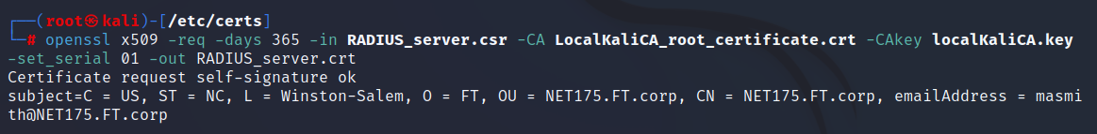
The local CA will verify the identity of the radius server, create a certificate and sign it with it's CA root certificate

ls -l
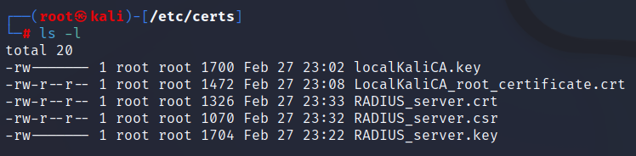

Configuring Radius server (we will be using the integrated one included with hostapd for this lab)

Time to configure the radius server

There are 2 possibilities
1. take advantage of our hostapd service which has a built in radius server
2. configure the freeradius server and change hostapd config to point to use the freeradius server

1. Using the hostapd built in radius (probably easiest given we’ve been using hostapd already

not now: ignore

Settings Summary:
- macaddr_acl: This controls MAC address filtering. MAC addresses are easily spoofed, so only consider the use of this to be augmenting other security measures you have in place.
- auth_algs: This is a bit field where the first bit (1) is for open auth, the second bit (2) is for Shared key auth (WEP) and both (3) is both.
- ignore_broadcast_ssid: This enables/disables broadcasting the SSID.
- wpa: This is a bit field like auth_algs. The first bit enables WPA1 (1), the second bit enables WPA2 (2), and both enables both (3)
- wpa_psk/wpa_passphrase: These establish what the pre-shared key will be for WPA authentication.
- wpa_key_mgmt: This controls what key management algorithms a client can authenticate with.
- wpa_pairwise: This controls WPA's data encryption.
- rsn_pairwise: This controls WPA2's data encryption. First, scratch macaddr_acl and ignore_broadcast_ssid from your priorities as they only enhance security (and even then, only slightly). Also, WEP has been effectively broken now, so unless you HAVE to support WEP, scratch that from your list. This just leaves WPA/WPA2. Per the draft standard, WPA2 is required for 802.11n, and as there are known attacks on WPA now, WPA2 is the recommended authentication and encryption suite to use. Fortunately, you can have both enabled at once. If Windows clients are going to be connecting, you should leave CCMP encryption out of the wpa_pairwise option, as some windows drivers have problems with systems that enable it.

Basic config with WPA and WPA2 enabled:
macaddr_acl=0
auth_algs=1
ignore_broadcast_ssid=0
wpa=3
wpa_passphrase=YourPassPhrase
wpa_key_mgmt=WPA-PSK
wpa_pairwise=TKIP
rsn_pairwise=CCMP

Config hostapd for TTLS client authentication
TTLS authentication allows the server to certify itself but no certificates are required from supplicant beyond knowing authentication username and password
https://web.mit.edu/freebsd/head/contrib/wpa/hostapd/hostapd.conf
To find this part of config search for : ##### Integrated EAP server

In hostapd.conf add:

# Use integrated EAP server instead of external RADIUS
# authentication server.
# This is also needed if hostapd is configured to act as a
# RADIUS authentication server.
eap_server=0

# Path for EAP server user database
eap_user_file=/etc/hostapd/hostapd.eap_user

# CA certificate (PEM or DER file) for EAP-TLS/PEAP/TTLS
ca_cert=/etc/certs/LocalKaliCA_root_certificate.pem

# Server certificate (PEM or DER file) for EAP-TLS/PEAP/TTLS
server_cert=/etc/RADIUS_server.pem

# Private key matching with the server certificate for RADIUS private_key.
private_key=/etc/certs/RADIUS_server.key

# Passphrase for private key (we are not using one but this is where you would provide it)
#private_key_passwd=secret passphrase

# Use integrated EAP server instead of external RADIUS authentication
# server. This is also needed if hostapd is configured to act as a RADIUS
# authentication server.
eap_server=0
# Path for EAP server user database
# If SQLite support is included, this can be set to "sqlite:/path/to/sqlite.db"
# to use SQLite database instead of a text file.
eap_user_file=/etc/hostapd.eap_user #this file is not present yet

Create certificates for TLS client authentication
EAP-TLS and PEAPv0/1 with TLS, one more set of certificates is required for client authentication.

Generate the CA key for TLS client authentication
openssl genrsa -out radius_root.key 2048
This is the key that will be used to self-sign and make yourself a certificate authority
generate the CA certificate using the CA key
openssl req -new -x509 -days 365 -key radius_root.key -out radius_root.crt

Generate the Certificate Signing Request and public certificate
client key
openssl genrsa -out NET175_client_private.key 2048
generate CSR with private key
openssl req -new -key NET175_client_private.key -out NET175_client_private.csr
Self-sign certificate using CA and generate public key
openssl x509 -req -days 365 -in NET175_client_private.csr -CA radius_root.crt -CAkey radius_root.key -set_serial 01 -out NET175_client_private.crt

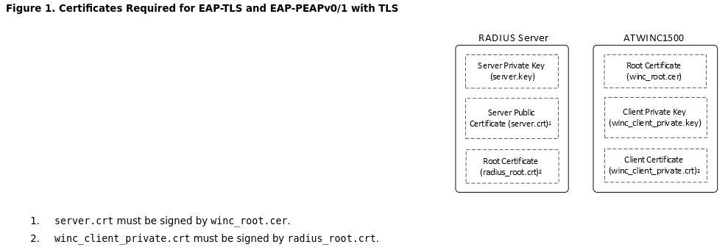

WE now have several different types of certificates to cover a variety of scenarios.

start firewalld service
firewall-cmd –get-active-zones
use public
use firewall-cmd –list to view currently active services
services needed:
ftp
radius
ssh
if missing
use firewall-cmd –add-service=ssh (repeat for radius and ftp)

Sources:
site: https://www.suse.com/c/creating-virtual-wlan-interfaces/

The virtual machine specifically used for this assignment is kali 2022.4 for Intel/AMD machines. You can explore more recent versions and/or machines for other architecture here: https://www.kali.org/get-kali/

https://www.digitalocean.com/community/tutorials/how-to-set-up-vsftpd-for-anonymous-downloads-on-ubuntu-16-04

swapping firewalld for ufw

https://access.redhat.com/documentation/en-us/red_hat_enterprise_linux/7/html/security_guide/sec-viewing_current_status_and_settings_of_firewalld

Generating keys and certificates for local CA and radius server
https://deliciousbrains.com/ssl-certificate-authority-for-local-https-development/#how-it-works

configuring freeradius server (includes generation of required CA keys)
https://onlinedocs.microchip.com/pr/GUID-3475A0DC-0448-48FB-9AAE-319A834637DE-en-US-3/index.html?GUID-6CCF008D-8580-46EF-8826-CBE62C3DDD8A

configuring hostapd with WPA2 in mind? Find: Authentication and Encryption on the page to get started:

https://wireless.wiki.kernel.org/en/users/documentation/hostapd

**the full hostapd.conf file with explanation of different amendments and authentication method configs:

https://web.mit.edu/freebsd/head/contrib/wpa/hostapd/hostapd.conf

